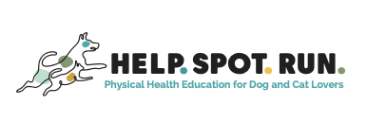
Barley the Yellow Lab

_________________________________________________________________________

History/presentation:
10 yrs, FS, 35lbs
- He was becoming less active – and he is typically full of life.
- New progressive difficulty getting up
- He was not moving as well as a tripod
- He was amputated 2 yrs ago as a treatment for cancer
- He can’t take most medication because he also has IBD and needs to take Budesonide
Specific diagnosis:
- Tarsal OA in his remaining back leg
- Painful lumbar spine due to compensation
- Maladaptive pain
Exam:
- He was smiling but sore and hesitant to let our rehab team massage his back.
- He was slipping on the slick floors and would opt out of some activities at home – which is not normal for him.
Treatments:
- Joint injections + Shockwave
- I treated him with SpryngTM OsteoCushion TechnologyTM in his right tarsus (ankle) and treated his back with shockwave from Kinas Medial Technologies.
30 days after his 2nd procedure:
- He is OFF ALL MEDS for pain!!
- Pain 2/10 instead of 5/10
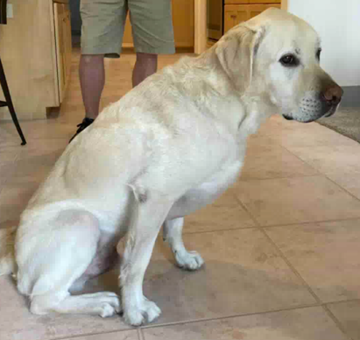
He is a wild man again! What a great life and
