“Oh, Henry!” the Golden Retriever

_________________________________________________________________________

History/presentation:
4 yrs, FS, 45lbs
- He was fearful of stairs and of jumping on to the bed
- He could never sit straight
- He gets upset stomach easily
- He has elevated kidney values
- He has partial congenital blindness

Specific diagnosis:
- Hip dysplasia with OA
- Food allergies
- Medication intolerance
- Retinal degeneration
- Early renal disease
- Maladaptive pain
Exam:
- It is hard for him to sit comfortably
- He was anxious with new experiences and strangers
- He would sometimes whimper when laying down
- He would refuse to climb stairs
Treatments:
- Joint injections + Shockwave + Stem cell therapy
- I treated him with SpryngTM OsteoCushion TechnologyTM in his hips, + SQ Anicell stem cells. I treated his back and hips with shockwave from Kinas Medial Technologies.
30 days after her procedure:
- He is OFF ALL MEDS for pain!!
- Pain 2/10 instead of 5/10
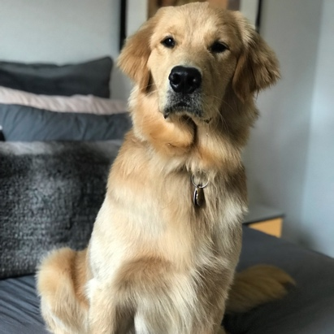
He is ruling the city of Chicago by stealing everyone’s hearts. No meds, no limping, no fear.

