Jasper the Shepard Mix

_________________________________________________________________________

History/presentation:
11 yrs, MN, 70lbs
- Limping alternating all 4 limbs x 2 years
- 5 types of pain medication
- Slow and not enjoying life
- Fearful of people
- Snapping at the human toddler
Specific diagnosis:
- Multiple joint OA – elbows, stifles, hips, shoulders
- Shoulder tendinopathy
- Maladaptive pain
Exam:
- Jasper was limping 2-3/6 in both front legs with pain in his shoulders and elbows, pain in his stifles and tons of back pain as a result.
Treatments:
- He was treated with medication to fight maladaptive pain, shockwave, and joint injections with SynamidTM and then a second treatment with injections with SpryngTM OsteoCushion TechnologyTM.

30 days after his 2nd procedure:
- He is OFF ALL MEDS EXCEPT Galliprant
- Pain 2/10 instead of 7/10
- See him on You Tube!

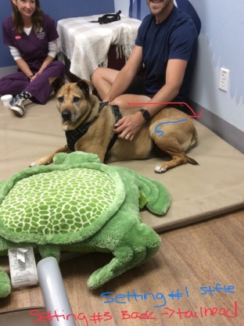

He is no longer afraid of people, will allow grooming, is not limping and can play with his toddler!

