Rosie the Heeler Mix

_________________________________________________________________________

History/presentation:
7 yrs, FS, 45lbs
- She was anxious and it was hard for her to settle down
- She was painful after play
- She was hard to train
- She was limping in her RF leg
Specific diagnosis:
- Hip dysplasia with OA
- Shoulder OA
- Shoulder tendinopathy
- Maladaptive pain
Exam:
- She was fearful of touch and so anxious that she was wild and a little grabby with food.
- She was limping consistently and having a hard time sitting still and sometimes sore to get up after laying
Treatments:
- Joint injections + Shockwave
- I treated him with SpryngTM OsteoCushion TechnologyTM in her shoulder and hips, and treated her back and shoulder tendons with shockwave from Kinas Medial Technologies.
30 days after her procedure:
- He is OFF ALL MEDS for pain!!
- Pain 2/10 instead of 5/10
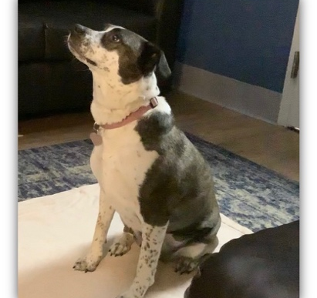
She is a new girl, no fear and playing with her kitten, with no lameness!

