Shelby the Golden Retriever

_________________________________________________________________________

History/presentation:
12 yrs, FS, 40lbs
- Elbow dysplasia + OA and lameness for life
- TPLO 2 years ago
- Tarsal OA
- Slow and not enjoying life as much
- New progressive difficulty getting up
Specific diagnosis:
- Multiple joint OA – elbows, stifle, new tarsal arthritis
- Shoulder tendinopathy
- Maladaptive pain
Exam:
- Shelby was nearly hobbling she was so sore in all 4 limbs.
- She has fought arthritis well for most of her life with rehab and laser, and PRP, SynamidTM and injections in the past.
Treatments:
- Joint injections + Shockwave
- I treated her with SpryngTM OsteoCushion TechnologyTM in her elbows and her tarsi (ankles) and treated her back with shockwave from Kinas Medial Technologies.
30 days after his 2nd procedure:
- She is OFF ALL MEDS EXCEPT Galliprant
- Pain 2/10 instead of 7/10
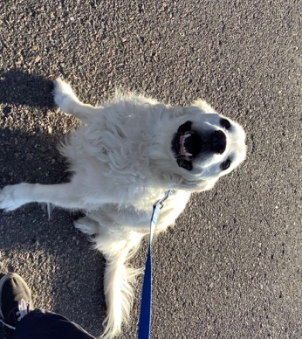
Watch her before and after video – you won’t believe how much easier it is for her to get up and to play!
