Spirit the Newfoundland

_________________________________________________________________________

History/presentation:
6 yrs, FS, 100lbs
- She laid around a lot like maybe she was lazy
- She didn’t want to play
- She limped consistently
- It was hard for her to get up and down
- She had custom leg braces for her deformed carpi (wrists)
Specific diagnosis:
- Laxity of the carpal ligaments (angular limb deformity) + Carpal OA
- Secondary elbow OA
- Secondary shoulder tendonitis
- Hip OA
- Lick granulomas
- Allergies
- Back pain
- Maladaptive pain
Exam:
- It is was impossible for her to sit
- It was hard for her to sit up even while laying
- She would refuse to get up
Treatments:
- Joint injections + Shockwave + Rehab Exercise + Home Laser Therapy
- I treated her with SpryngTM OsteoCushion TechnologyTM in her hips hips, + SynamidTM in her carpi and elbows and shoulders. I treated her back and hips and stifles with shockwave from Kinas Medial Technologies.
30 days after her procedure:
- She has reduced her MEDS for pain
- Pain 2/10 instead of 5/10
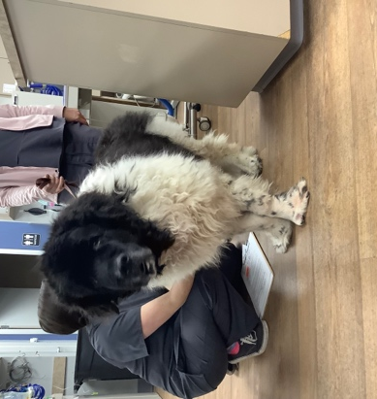
She can jump up!! She needs no braces. She swims 10-12 laps in the pool!
You would not believe it!
